**Test Output Doc**

1. **Catalog service lookup:  
     
   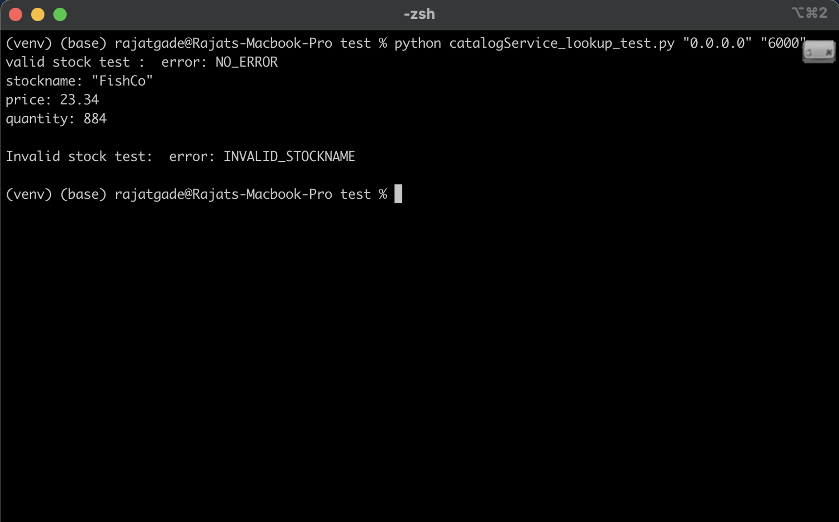**
2. **Catalog service buy_or_sell:  
   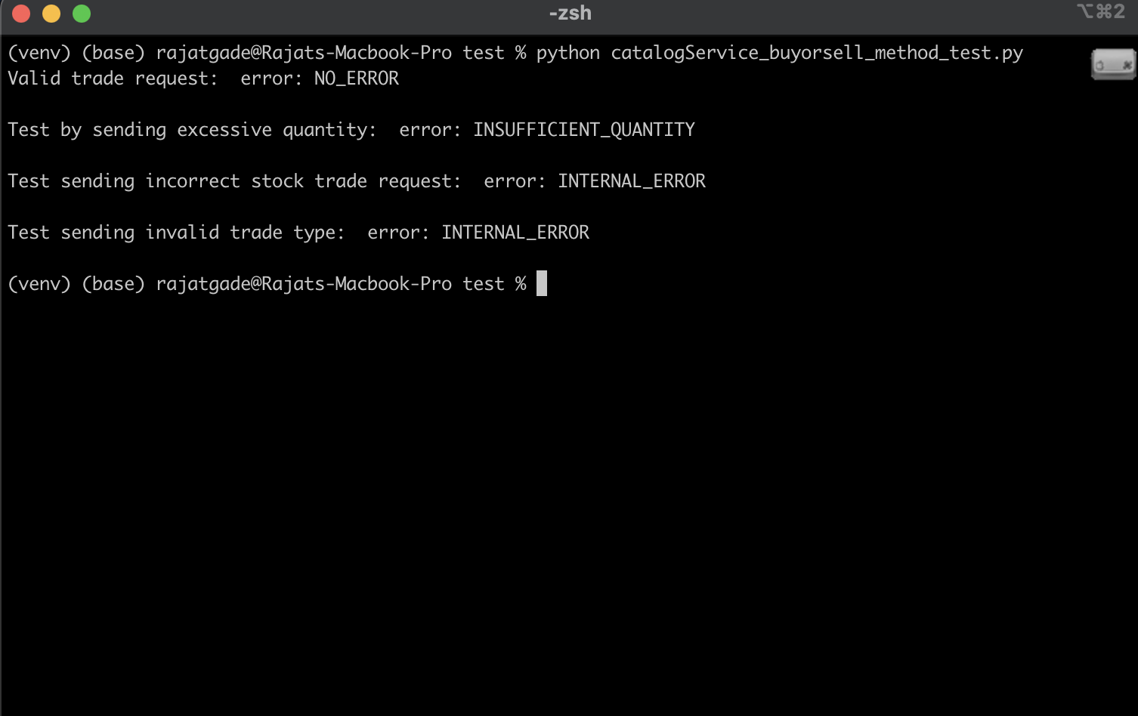**
3. **Order Service trade:  
     
   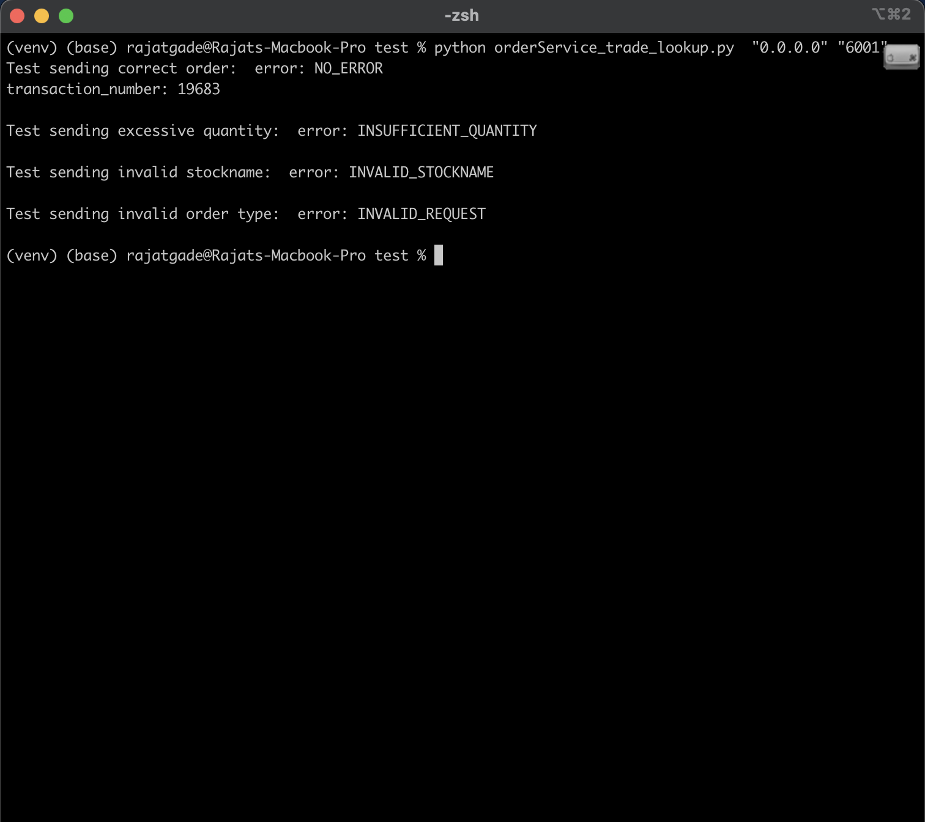**
4. **Front end server test:  
   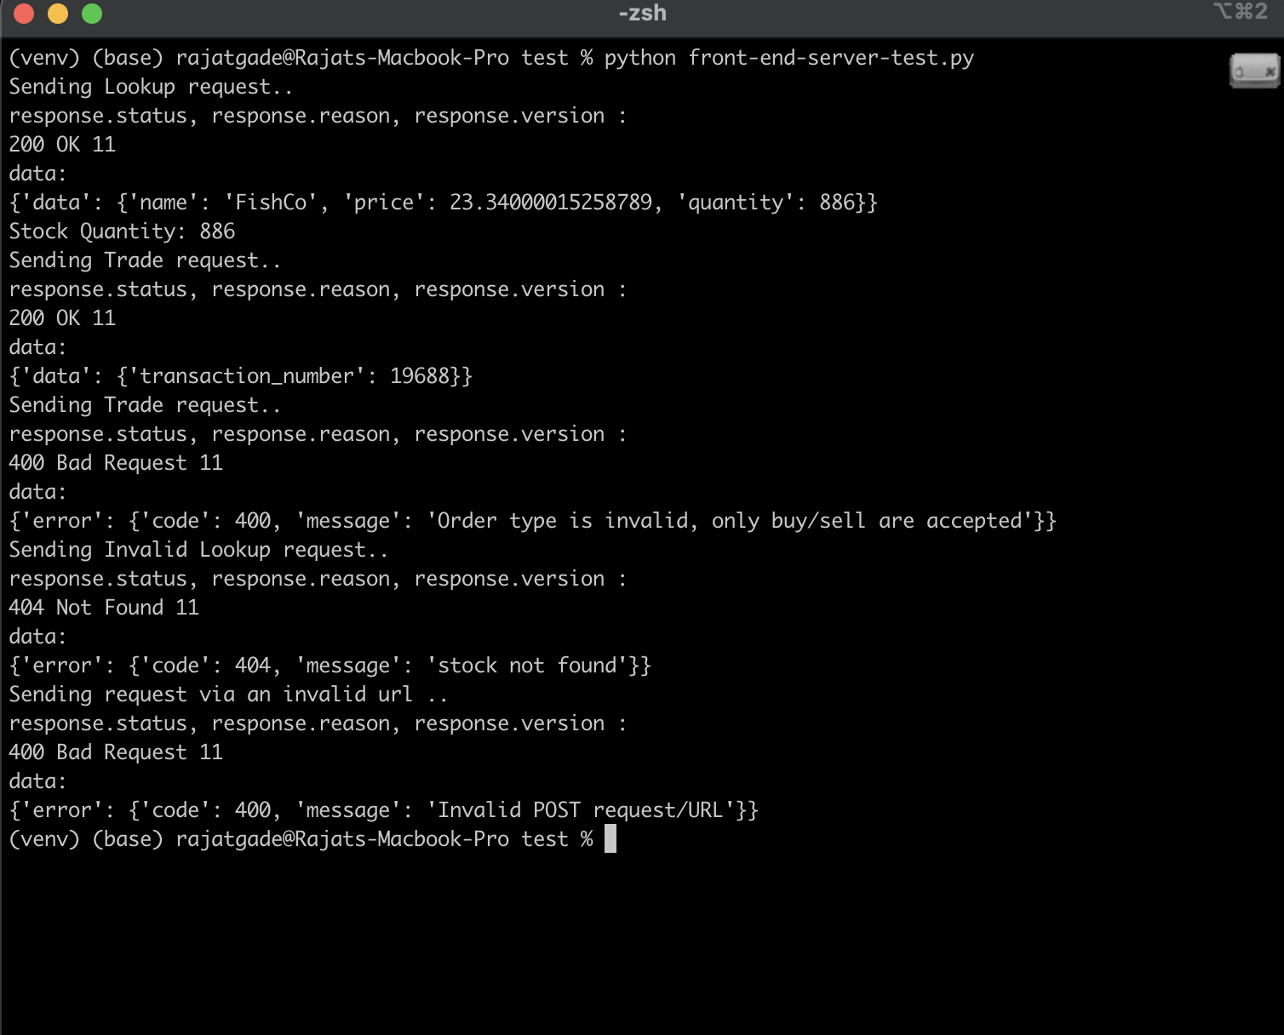**
5. **Load test (client on host and servers in respective docker containers):  
   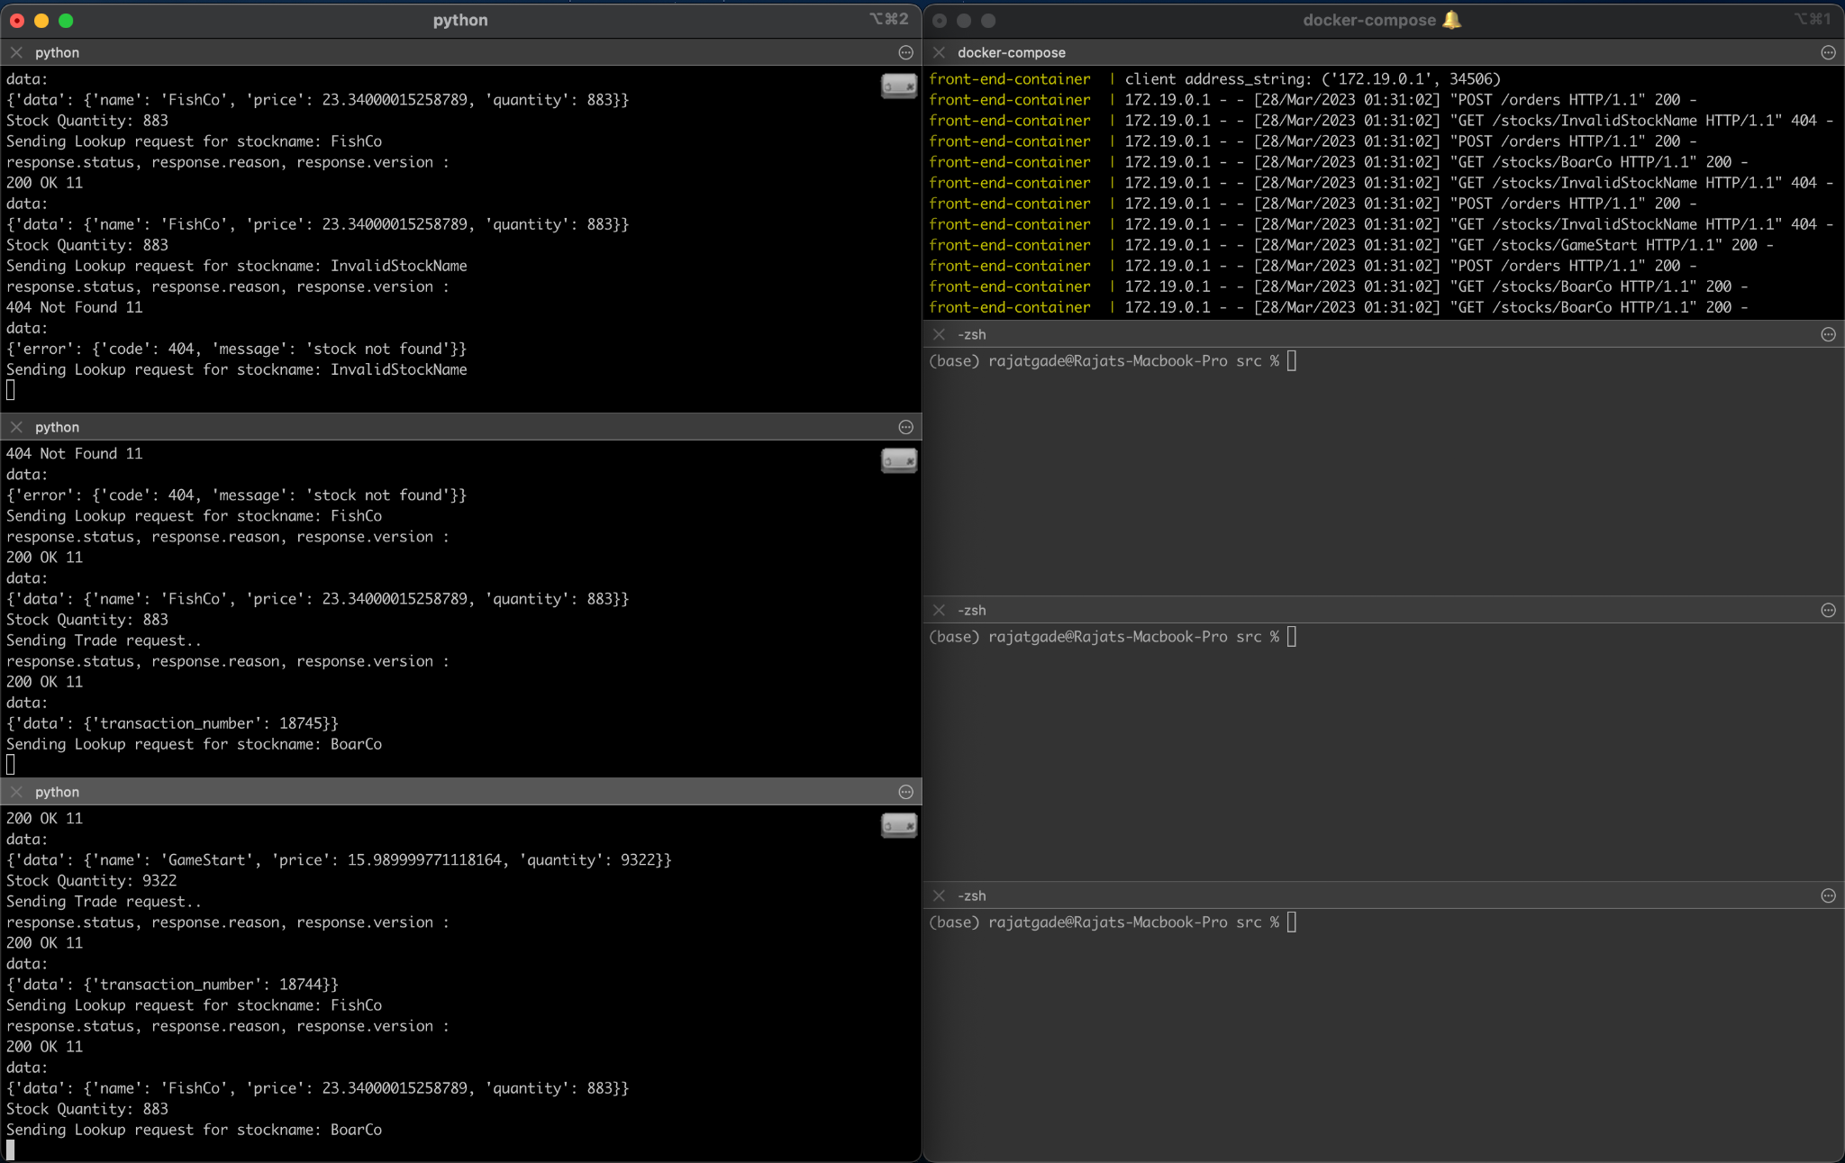**
6. **Load test (client on local and servers running on edlab):  
   